EXPERIMENT: Breadth First Search
Aim:
To implement the Breadth First Search (BFS) algorithm using Python to traverse a graph and find the path from a starting node.

Objectives:
- To understand the working principle of Breadth First Search algorithm.
- To implement BFS traversal using a queue data structure.
- To visit graph nodes level by level.
- To find a path between source and destination nodes.
- To display the order of nodes visited during traversal.

Algorithm: Breadth First Search (BFS)
Step 1: Start the program.
Step 2: Create a graph using an adjacency list.
Step 3: Initialize an empty queue and visited list.
Step 4: Insert the starting node into the queue and mark it as visited.
Step 5: Remove the first node from the queue and display it.
Step 6: Add all unvisited adjacent nodes to the queue.
Step 7: Repeat Steps 5 and 6 until the queue becomes empty.
Step 8: Display the BFS traversal order.
Step 9: Stop the program.

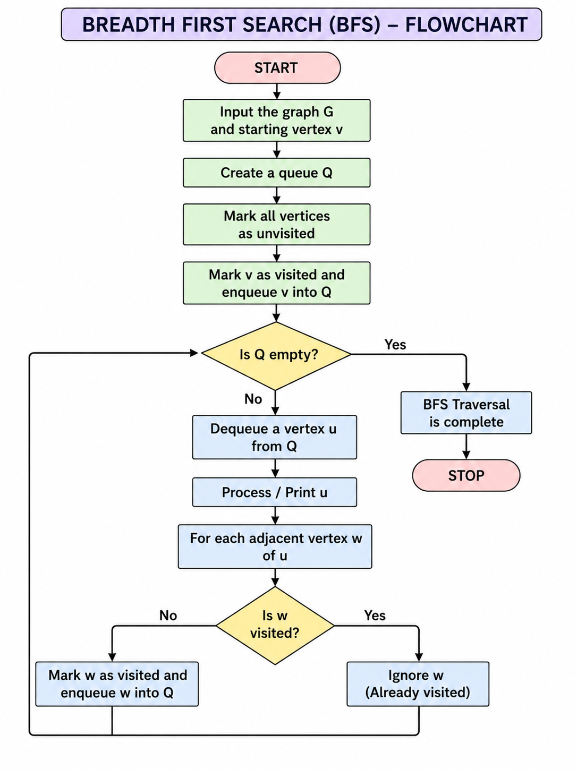

Source Code
# Breadth First Search (BFS) Implementation

from collections import deque

# Graph representation
graph = {
'A': ['B', 'C'],
'B': ['D', 'E'],
'C': ['F', 'G'],
'D': [],
'E': [],
'F': [],
'G': []
}

# BFS Function
def bfs(start):
visited = []
queue = deque()

# Add starting node
queue.append(start)
visited.append(start)

while queue:
node = queue.popleft()
print(node, end=" ")

# Visit adjacent nodes
for neighbour in graph[node]:
if neighbour not in visited:
visited.append(neighbour)
queue.append(neighbour)

# Main program
print("BFS Traversal:")
bfs('A')

OUTPUT

